**Seoul Smart Mobility**

**Weather Impact and Rental Trend Analysis**

**Project Title-** Seoul Smart Mobility: Weather Impact and Rental Trend Analysis

**Project Summary-**

This project focuses on analyzing Seoul’s public bike-sharing system using Power BI. The goal is to uncover key insights about bike rental patterns across different seasons, weather conditions, and time periods. The dataset includes information such as date, hour, temperature, humidity, rainfall, and rental count.  
Through this analysis, the project aims to help city planners and transport departments understand when and why people rent bikes more, and how factors like temperature, humidity, and rainfall influence public bike usage.  
Interactive dashboards and KPIs are used to provide a clear, data-driven view of the overall rental behavior throughout the year.

**Problem Statement-**

The Seoul city government provides public bikes for sustainable urban mobility. However, understanding how external factors (like weather and time) affect bike rentals is difficult using raw data.  
The main problem is identifying patterns and relationships between environmental conditions and rental demand — without an analytical dashboard, decision-makers cannot easily determine:

* Which seasons or hours have peak demand
* How weather impacts the number of rentals
* Which days show lower or zero activity

Therefore, there is a need for a visual and analytical dashboard that provides meaningful insights for better planning and management.

**Objective-**

The primary objectives of this Power BI project are:

1. To analyze and visualize **bike rental patterns** by day, hour, and season.
2. To study the **impact of temperature, humidity, and rainfall** on total bike rentals.
3. To identify **peak rental hours** and functioning days.
4. To compare **seasonal trends** and understand weather influence on demand.
5. To create an **interactive Power BI dashboard** that supports data-driven decision-making.

**Abstract**

This project presents a comprehensive analysis of the Seoul Bike Sharing System using Microsoft Power BI. The aim is to explore how different factors such as season, temperature, humidity, rainfall, and time affect the number of rented bikes in Seoul city.

The dataset contains hourly rental records along with various weather conditions. The data was cleaned, transformed, and enriched using Power Query, and several DAX measures were created for deeper insights.

Interactive dashboards were designed to visualize trends such as seasonal performance, hourly usage, weather impact, and functioning days. The report highlights that bike rentals increase during summer and moderate temperatures, while rainy and colder days show a decline in usage.

Overall, this Power BI dashboard helps in understanding the relationship between weather and rental demand, which can assist city planners and transportation departments in improving resource management, bike availability, and promoting eco-friendly travel.

**Conclusion –**

This project demonstrates the power of data visualization in converting raw datasets into meaningful, actionable insights.

**Tools and Technologies Used**

This project was developed using the following tools and technologies:

|  |  |
| --- | --- |
| **Tool / Technology** | **Purpose / Use** |
| **Microsoft Power BI** | The main tool used for data visualization, dashboard creation, data transformation (Power Query), and DAX-based calculations. |
| **Microsoft Excel** | Used for initial data inspection, understanding the dataset, and verifying basic data values before importing into Power BI. |
| **CSV File (Dataset)** | The dataset containing Seoul bike rental information was provided in CSV format and imported into Power BI for analysis. |
| **Microsoft Word** | Used for preparing the final project documentation and report. |

The complete analysis, data modeling, and dashboard design were performed in **Power BI**.  
**Excel** was used only for checking the data quality, while **Word** was used to create the final written report.

**Data Description and Preparation**

**Dataset Overview-**

The dataset used in this project is the Seoul Bike Sharing Data, which contains hourly records of bike rentals along with weather-related information such as temperature, humidity, wind speed, visibility, rainfall, and more.  
The dataset originally contained 8,760 rows (representing each hour of the year) and 14 columns before transformation.

The primary objective of this dataset is to analyze how environmental and seasonal factors affect the number of rented bikes across different time periods.

**Column Details-**

This section explains how the original dataset’s columns were refined during data preparation. It compares the raw data (before transformation) with the cleaned and structured data (after transformation).  
It highlights renamed columns, added calculated fields (like Month_Name, Day_Name, Year), and removed unnecessary ones (like Snowfall).  
This helps to understand how raw CSV data was converted into analysis-ready form.

|  |  |  |  |
| --- | --- | --- | --- |
| **Before Transformation** | **Description / Purpose** | **After Transformation** | **Description / Purpose** |
| Date | Represents the date when bike rentals were recorded. Used for time-series and trend analysis. | ID | Unique identifier for each record. |
| Rented Bike Count | Number of bikes rented during the given hour. This is the main measure for analysis. | Date | Date of rental activity. |
| Hour | Indicates the hour of the day (0–23). Helps identify peak and off-peak rental hours. | Bike_Count | Total number of rented bikes. |
| Temperature(°C) | Air temperature in degrees Celsius. Used to analyze how temperature affects rental demand. | Hour | Represents the hour of the day. |
| Humidity(%) | Relative humidity percentage. Used to study the effect of moisture level on rentals. | Temperature_C | Temperature in °C. |
| Wind speed (m/s) | Speed of wind in meters per second. Used to see if wind affects bike usage. | Humidity | Humidity percentage. |
| Visibility (10m) | Visibility level measured in 10-meter units. | Wind_Speed_mps | Wind speed in meters per second. |
| Dew point temperature(°C) | Temperature at which dew forms. Indicates air moisture. | Visibility_10m | Visibility value. |
| Solar Radiation (MJ/m2) | Solar energy received per square meter. | DewPoint_C | Dew point temperature. |
| Rainfall(mm) | Rainfall amount in millimeters. Used to understand impact of rain on rentals. | Rainfall_mm | Rainfall in millimeters. |
| Snowfall (cm) | Snowfall in centimeters. (Removed as not relevant for this dataset.) | Season | Represents the season (Winter, Spring, Summer, Autumn). |
| Seasons | Indicates the current season. | Holiday | Whether the day was a holiday or not. |
| Holiday | Indicates whether the day was a holiday. | Functioning_Day | Whether the rental system was working (Yes/No). |
| Functioning Day | Shows if the bike system was operational that day. | Day_Name, Month_Name, Year, Weekday_Weekday | Added calculated columns for time-based analysis. |

**Data Cleaning Summary-**

This section describes all cleaning actions performed in Power Query before loading data into Power BI.  
It includes steps like removing null values, deleting duplicate rows, handling errors, removing unwanted columns, and adding new calculated columns.  
The summary also shows how many rows or columns changed after each step — ensuring data accuracy and consistency.

|  |  |  |  |  |  |  |  |
| --- | --- | --- | --- | --- | --- | --- | --- |
| **Sr. No.** | **Applied Step** | **Rows Before** | **Rows After** | **Effect (Rows)** | **Columns Before** | **Columns After** | **Effect (Columns)** |
| 1 | Extract Data from CSV | 8760 | 8760 | 0 | 14 | 14 | 0 |
| 2 | Remove Errors | 8760 | 8760 | 0 | 14 | 14 | 0 |
| 3 | Remove Blank Rows | 8760 | 8760 | 0 | 14 | 14 | 0 |
| 4 | Remove Duplicates | 8760 | 8760 | 0 | 14 | 14 | 0 |
| 5 | Remove Column (Snowfall) | 8760 | 8760 | 0 | 14 | 13 | -1 |
| 6 | Add Column (Day_Name) | 8760 | 8760 | 0 | 13 | 14 | +1 |
| 7 | Add Column (Month_Name) | 8760 | 8760 | 0 | 14 | 15 | +1 |
| 8 | Add Column (Year) | 8760 | 8760 | 0 | 15 | 16 | +1 |
| 9 | Add Column (Weekday_Weekday) | 8760 | 8760 | 0 | 16 | 17 | +1 |

**Data Transformation and Wrangling Steps-**

This part focuses on how data was further transformed to make it suitable for visual analysis.  
It includes operations like adding new columns (e.g., Month_Name, Year, Weekday), creating calculated measures, grouping or merging fields, and preparing relationships.  
These transformations help uncover deeper insights such as seasonal patterns and hourly rental behavior.

|  |  |  |
| --- | --- | --- |
| **Sr. No.** | **Column Name** | **Performed Activity** |
| 1 | Snowfall (cm) | Removed as the data was mostly null. |
| 2 | Day_Name | Added custom column using Date function (Date.DayOfWeekName). |
| 3 | Month_Name | Added column to categorize records by month name. |
| 4 | Year | Extracted year from the Date column. |
| 5 | Weekday_Weekday | Added column to mark weekdays/weekends. |

**Storytelling KPIs and Visuals-**

Key Performance Indicators (KPIs) are the main measurable values used to evaluate the overall performance of the bike rental system. They help in identifying important trends and understanding how different factors like weather, season, and time affect bike rentals.

* **Key KPIs-**

This section highlights the main measurable metrics used to analyze the bike rental data.  
Examples include **Total Bike Rentals**, **Average Temperature**, **Average Humidity**, and **Total Rainfall**.  
KPIs help in quickly understanding the business performance and weather impact on rentals.

|  |  |  |  |
| --- | --- | --- | --- |
| **Sr. No.** | **KPI Name** | **Description** | **Formula (DAX)** |
| 1 | Total Bike Rentals | Total number of bikes rented. | SUM([Bike_Count]) |
| 2 | Average Temperature (°C) | Average weather condition. | AVERAGE([Temperature_C]) |
| 3 | Average Humidity (%) | Measures air moisture level. | AVERAGE([Humidity]) |
| 4 | Total Rainfall (mm) | Total rainfall recorded. | SUM([Rainfall_mm]) |
| 5 | Functioning Days | Number of active operating days. | DISTINCTCOUNT([Date]) (with Functioning_Day = “Yes”) |

* **Dashboard Visuals-**

This section contains all visual charts and graphs created in Power BI to represent insights from the dataset.  
It includes visuals like line charts for rental trends, column charts for season-wise comparison, scatter plots for temperature impact, and heatmaps for hourly or weekday analysis.  
Each visual is designed to tell a clear story based on data.

|  |  |  |  |  |
| --- | --- | --- | --- | --- |
| **Sr. No.** | **Chart Name** | **Columns Used** | **Visual Type** | **Purpose / Insight** |
| 1 | Rentals Over Time | Date, Bike_Count | Line Chart | Shows trend across the year. |
| 2 | Rentals by Season | Season, Bike_Count | Column Chart | Compare seasonal rental patterns. |
| 3 | Rentals by Month | Month_Name, Bike_Count | Column Chart | Analyze monthly performance. |
| 4 | Rentals by Day of Week | Day_Name, Bike_Count | Bar Chart | Compare weekday vs weekend usage. |
| 5 | Rentals vs Temperature | Temperature_C, Bike_Count | Scatter Chart | Shows how temperature affects rentals. |
| 6 | Weather Impact | Weather_Type, Bike_Count | Pie/Column Chart | Compare rainy vs clear days. |
| 7 | Hourly Rentals | Hour, Bike_Count | Line/Area Chart | Identify morning and evening peaks. |

* **Advanced Visuals-**

These are specialized or combined visuals that provide deeper insights beyond basic charts.  
Examples include:

1. Heatmaps for hour vs day pattern detection
2. Scatter plots for weather correlation
3. Matrix visuals for season-temperature relationships  
   Such visuals enhance analytical storytelling and make the dashboard more interactive.

|  |  |  |  |  |
| --- | --- | --- | --- | --- |
| **Sr. No.** | **Chart Name** | **Columns Used** | **Visual Type** | **Insight / Purpose** |
| 1 | Season + Temperature | Season, Temperature_C (grouped), Avg Bike_Count | Matrix / Heatmap | Identify best temperature range per season. |
| 2 | Hour vs Day Name | Day_Name, Hour, Bike_Count | Heatmap | See which days and hours have high usage. |
| 3 | Correlation Visualization | Humidity, Bike_Count, Temperature, Rainfall | Scatter Chart | Check correlation between humidity and rentals. |
| 4 | Functioning vs Non-Functioning Day | Functioning_Day, Bike_Count | Clustered Bar | Compare operational vs non-operational days. |

* **Filters / Slicers-**

Filters and slicers were added in the dashboard to make the report dynamic and user-interactive.

Users can filter the data by Season, Holiday, or Month to explore rentals under different conditions.

These slicers help viewers analyze data from multiple perspectives easily.

|  |  |  |  |
| --- | --- | --- | --- |
| **Sr. No.** | **Slicer Name** | **Used Column** | **Purpose** |
| 1 | Season | Season | Filter data season-wise. |
| 2 | Holiday | Holiday | Show difference between holidays and normal days. |
| 3 | Month | Month_Name | Filter data for specific months. |

**Dashboard Screenshots-**

To provide a better understanding of the Power BI dashboard and its analytical visuals, the following screenshots have been added. These images represent the complete view of the project, including both key KPIs and advanced insights.

The first screenshot highlights the **main KPI section**, showing metrics such as *Total Bike Rentals, Average Temperature, Average Humidity, Total Rainfall,* and *Functioning Days*. These KPIs provide an overall summary of the dataset and help in understanding general trends.

The second screenshot displays the **Advanced Analysis section**, which includes detailed visualizations like *Season vs Temperature Heatmap, Hourly Rental Patterns, Correlation Analysis,* and *Functioning Day Comparison*. These visuals help uncover deeper insights and patterns in the bike rental behavior based on weather and time factors.

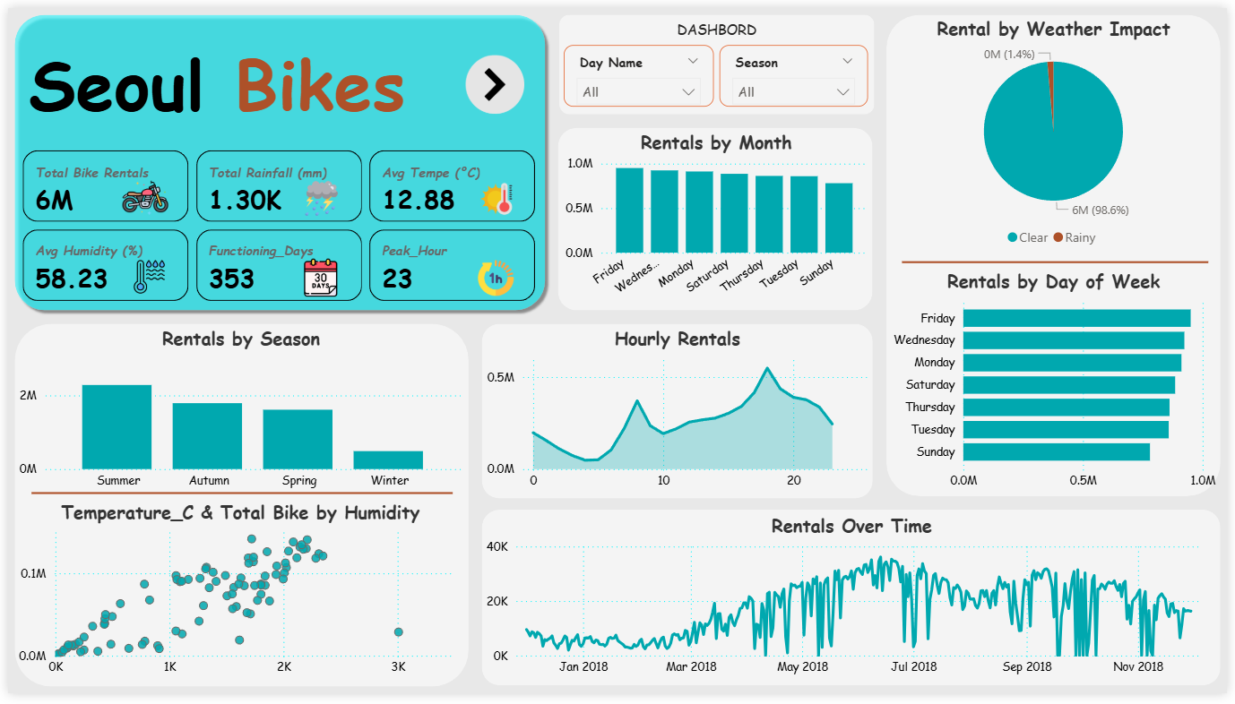

**Figure 1:** Power BI Dashboard – Key KPIs and Summary View

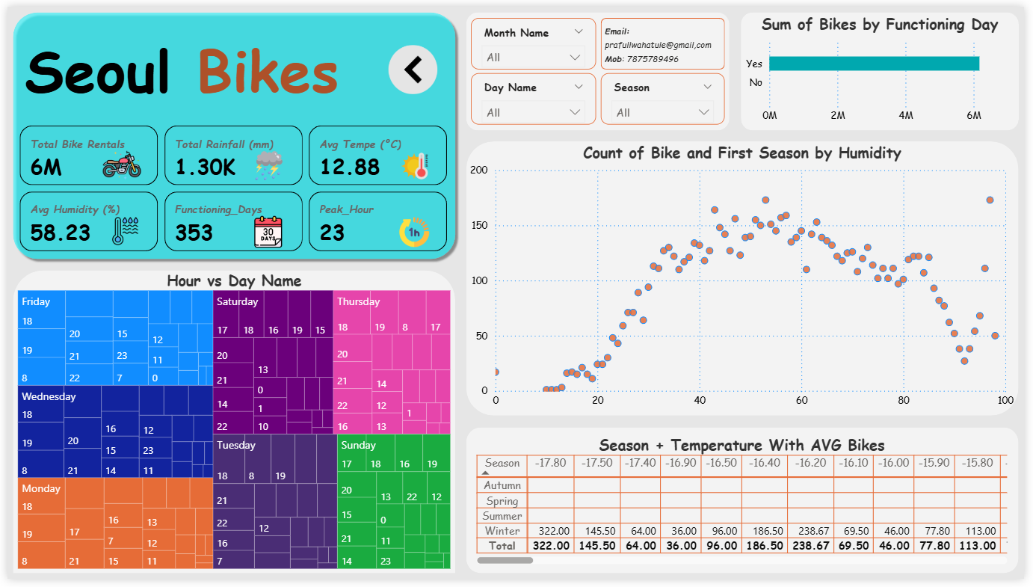

**Figure 2:** Power BI Dashboard – Advanced Analysis and Insights View

**Insights & Findings**

After analyzing the Seoul Bike Sharing dataset in Power BI, several important insights were discovered from the dashboards and visuals. These findings help us understand the key factors that affect the number of bike rentals and user behavior patterns.

1. Seasonal Impact:  
   Bike rentals are highly influenced by seasons. The number of rentals was highest during Summer and Autumn, while it dropped significantly in Winter due to low temperature and unfavorable weather conditions.
2. Hourly Patterns:  
   Rentals show clear time-based trends — the highest activity occurs during morning (8–9 AM) and evening (5–7 PM) hours, which indicates strong usage during office commute times.
3. Day-wise Trends:  
   Weekdays, especially Monday to Friday, have a higher rental count compared to weekends. However, on some weekends with good weather, the rentals increase, showing that weather conditions can override day patterns.
4. Temperature Relationship:  
   A moderate temperature (between 20°C to 28°C) shows the highest bike usage. Rentals decrease when the temperature is too low or too high.
5. Weather and Rainfall Effect:  
   Days with rainfall recorded significantly lower rentals, proving that rainy conditions directly reduce usage. Clear weather days are the most active in terms of bike demand.
6. Humidity and Correlation:  
   A negative correlation was seen between Humidity and Bike Count, meaning that higher humidity slightly reduces the rental count.
7. Functioning Days:  
   Almost all data days were functioning, showing consistent system performance, with a few non-functioning days having negligible effect on total rentals.

Overall, these insights help in understanding user preferences, environmental effects, and operational performance for better decision-making and service optimization.

**Conclusion**

The analysis of the Seoul Bike Sharing dataset through Power BI provided meaningful conclusions about urban mobility, weather influence, and rental demand patterns. The dashboard effectively summarizes large datasets into interactive visuals, allowing easy exploration of trends and correlations.

The findings clearly show that bike usage depends strongly on temperature, season, and rainfall. Rentals increase during warm and pleasant seasons and decrease in extreme weather conditions. The clear hourly and daily usage trends highlight how the bike-sharing service is primarily used for daily commuting.

This Power BI project demonstrates the power of data visualization and analytical storytelling. By combining KPIs, charts, and advanced visuals, it delivers a complete understanding of how weather and time factors influence bike rental behavior.

In real-world applications, such insights can help city planners, transportation departments, and bike-sharing companies to optimize resource allocation, plan maintenance schedules, and improve customer experience.

Thus, this project successfully fulfills its objective — to extract meaningful insights from raw data and present them through an interactive and visually engaging Power BI dashboard.